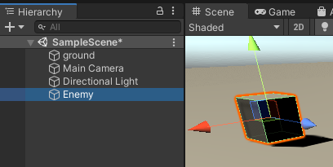Enemy AI Patrol Tutorial: how to code a simple patrol script in C# that can then be used in whatever 2D or 3D game.

1. Make sure you have your Enemy character in the scene

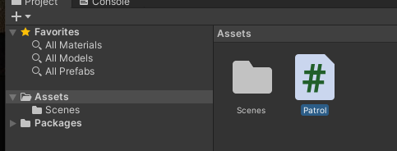

1. Start off by creating a new C# script and call it Patrol

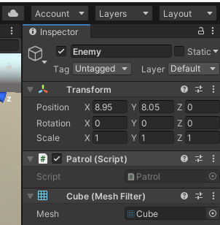

1. Drag and drop it into the Enemies Inspector
2. Double click the script to open it and begin programming – this moves the enemy to a random spot:

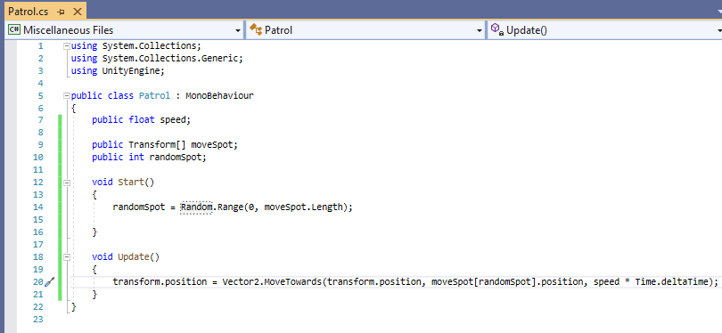

1. Now the enemy moves to a random spot – in the same script, create an If statement checking if it’s reached their spot, and if it has – make it wait a few seconds before moving to another random location:

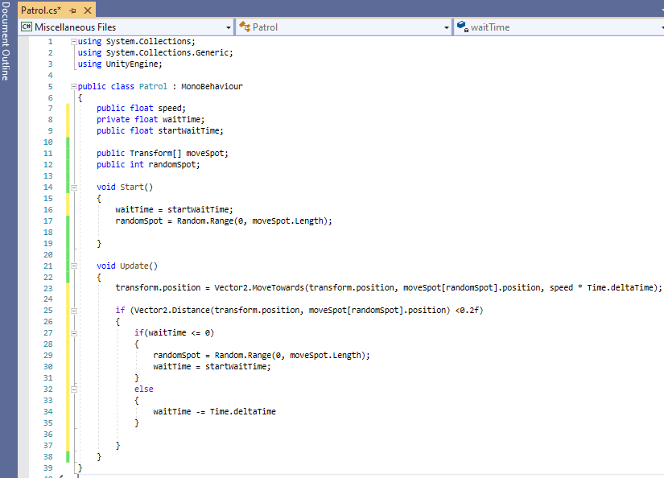

1. 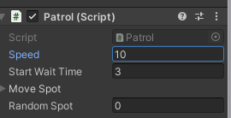Go back to Unity and, on the enemy, Set the speed and Start Wait Time of the enemy
2. 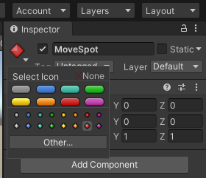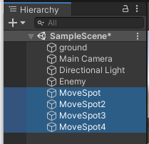Create a bunch of empty game object called MoveSpot (will act as the positions the enemy can move to

A nice unity tool that you can use to see your empty game objects is by using an icon:

Once created, place each game object wherever you like in the scene (wherever you want the enemy to go to)

1. 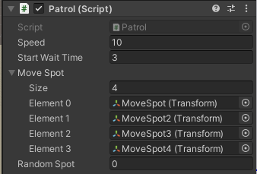Another good unity tool is locking the inspector – go to the enemy in the hierarchy and click this button in its inspector:

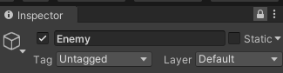This will lock the enemy’s inspector window which will allow you to easily drag and drop all the MoveSpots into the patrol script:

1. Click play and the enemy should be moving around the scene perfectly.